DBMS LAB ASSIGNMENT-1

Name: K.Rehasree

Reg.no:19BCS057

ER-DIAGRAM:

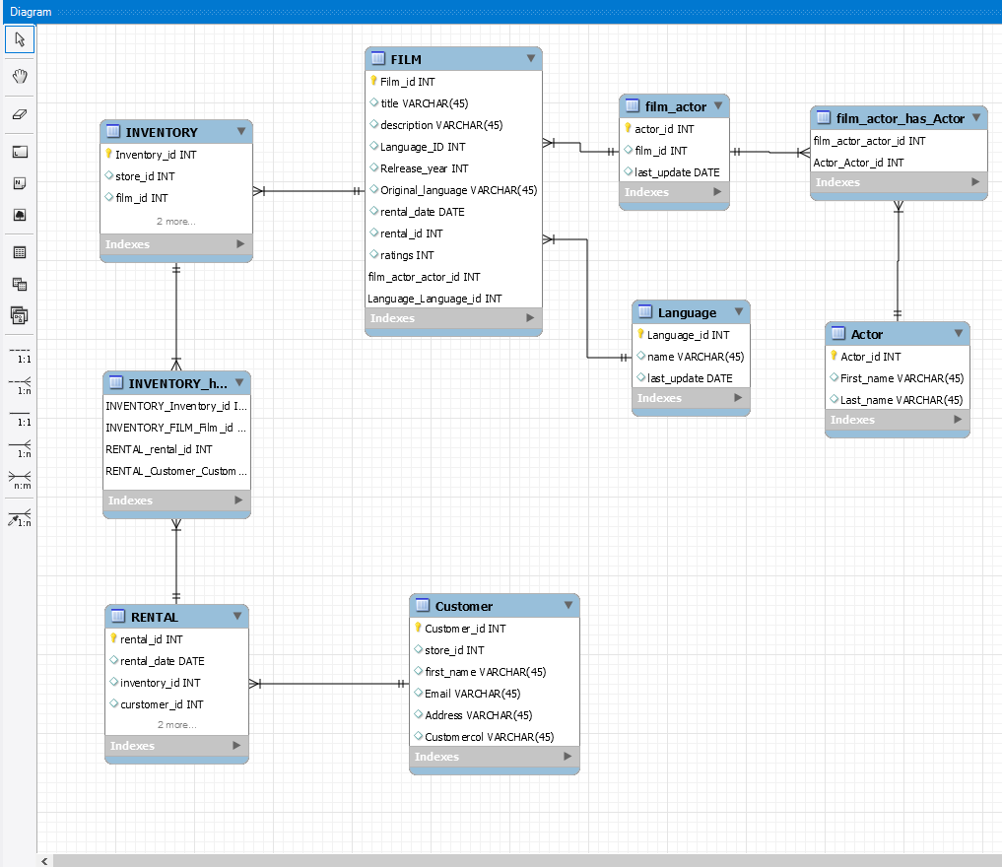

* No weak entities cause every table has a primary key